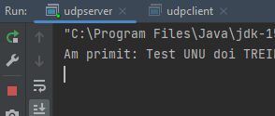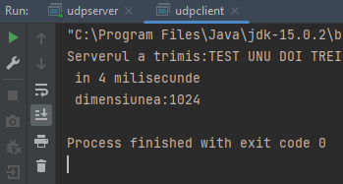Tema 2

Am reusit sa trimit date de la server la client si sa le afisez dimensiunea si timpul necesar pentru trimitere.

CLIENT

package org.example;  
  
import java.io.BufferedReader;  
import java.io.InputStreamReader;  
import java.net.DatagramPacket;  
import java.net.DatagramSocket;  
import java.net.InetAddress;  
import java.util.Date;  
  
class udpclient {  
 public static void main(String args[]) throws Exception {  
// BufferedReader inFromUser = new BufferedReader(new InputStreamReader(System.in));  
 DatagramSocket clientSocket = new DatagramSocket();  
 InetAddress IPAddress = InetAddress.*getByName*("localhost"); //ip-ul calculatoruui  
 byte[] sendData;  
 byte[] receiveData = new byte[1024];  
 String sentence = "Test UNU doi TREI";  
 sendData = sentence.getBytes();  
  
 Date date = new Date();  
 long time1 = date.getTime();  
  
 DatagramPacket sendPacket = new DatagramPacket(sendData, sendData.length, IPAddress, 3005);  
 clientSocket.send(sendPacket);  
 DatagramPacket receivePacket = new DatagramPacket(receiveData, receiveData.length);  
 clientSocket.receive(receivePacket);  
 String modifiedSentence = new String(receivePacket.getData());  
  
 Date date2 = new Date();  
 long time2 = date2.getTime();  
  
 System.*out*.println("Serverul a trimis:" + modifiedSentence + " \n in " + (time2 - time1) + " milisecunde" + "\n dimensiunea:" + receivePacket.getLength());  
 clientSocket.close();  
 }  
}

SERVER

package org.example;  
  
import java.net.DatagramPacket;  
import java.net.DatagramSocket;  
import java.net.InetAddress;  
  
class udpserver {  
 public static void main(String args[]) throws Exception {  
 DatagramSocket serverSocket = new DatagramSocket(3005);  
 byte[] receiveData = new byte[1024];  
 byte[] sendData;  
 while (true) {  
 DatagramPacket receivePacket = new DatagramPacket(receiveData, receiveData.length);  
 serverSocket.receive(receivePacket);  
 String sentence = new String(receivePacket.getData());  
 System.*out*.println("Am primit: " + sentence);  
 InetAddress IPAddress = receivePacket.getAddress();  
 int port = receivePacket.getPort();  
 String capitalizedSentence = sentence.toUpperCase();  
 sendData = capitalizedSentence.getBytes();  
 DatagramPacket sendPacket = new DatagramPacket(sendData, sendData.length, IPAddress, port);  
 serverSocket.send(sendPacket);  
 }  
 }  
}